**Submitted To: Engr. Ammad Khalil**

**Submitted By: Shah Raza (44)**

**Ashiq Ullah (77)**

**Section: B**

**Date: 23/10/2018**

DEPARTMENT OF COMPUTER SYSTEM ENGINEERING, UET, PESHAWAR

Computer Fundamentals

lab report #3

2018

Table of Contents

Screen Elements 3

To Create a New Word Document 6

Navigating in a Document 7

To Display Different Views 7

Editing and Proofing Documents 8

Selecting Text 8

Deleting Text 8

Cut, Copy and Paste 9

To Cut Text: 9

To Copy Text 9

To Paste Text 9

Formatting a Document to Make Font Changes 9

Working with Graphics 10

Inserting Shapes 10

Insert Text to Shapes 11

Format Shapes 11

Inserting Text Boxes 11

WordArt 11

Inserting Equations 12

Live Preview 12

Formatting a Paragraph 13

Previewing and Printing a Document 13

Saving and Closing a New Document 14

To Save a New Document 14

To Close a Document 15

**INTRODUCTION TO MICROSOFT WORD 2016**

**Screen Elements:**

**Quick Access Toolbar Title Bar Tell Me Ribbon**

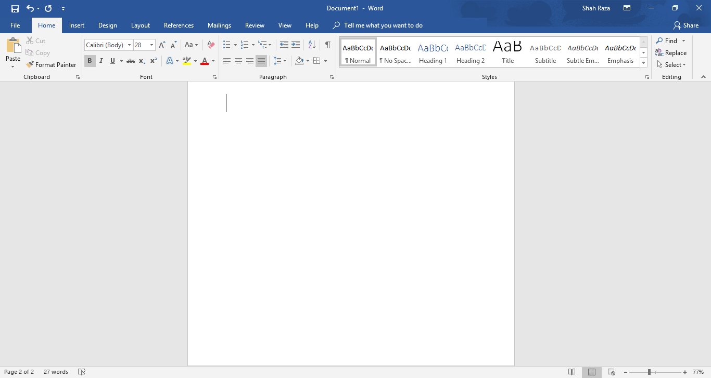

**View Toolbar**

**Zoom**

**Status Bar**

**Dialog Box Launcher**

**Groups**

**Tabs**

**File Menu**

* **File Menu:** The File tab will bring you into the Backstage View. The Backstage View is where you manage your files and the data about them – creating, opening, printing, saving, inspecting for hidden metadata or personal information, and setting options.
* **Ribbon:** An area across the top of the screen that makes almost all the capabilities of Word available in a single area.
* **Tabs:** An area on the Ribbon that contains buttons that are organized in groups. The default tabs are Home, Insert, Design, Layout, References, Mailings, Review, View and EndNote X5.
* **Title Bar:** A horizontal bar at the top of an active document. This bar displays the name of the document and application. At the right end of the Title Bar is the Minimize, Maximize and Close buttons.
* **Groups**: A group of buttons on a tab that are exposed and easily accessible.
* **Dialog Box Launcher:** A button in the corner of a group that launches a dialog box containing all the options within that group.
* **Status Bar:** A horizontal bar at the bottom of an active window that gives details about the document.
* **View Toolbar:** A toolbar that enables, adjusts, and displays different views of a document.
* **Zoom:** Magnifies or reduces the contents in the document window.
* **Quick Access Toolbar:** A customizable toolbar at the top of an active document. By default, the Quick Access Toolbar displays the Save, Undo, and Repeat buttons and is used for easy access to frequently used commands. To customize this toolbar, click on the dropdown arrow and select thecommands you want to add.
* **Tell Me:** This is a text field where you can enter words and phrases about what you want to do next and quickly get to features youwant to use or actions you want to perform.You can also use TellMe to findhelp about what you're looking for, or touse Smart Lookup toresearch or define the term you entered.

**Contextual Tabs** are designed to appear on the Ribbon when certain objects or commands are selected. These tabs provide easy access to options specific to the selected object or command. For example, the commands for editing a picture will not be available until the picture is selected, at which time the Picture Tools tab will appear.

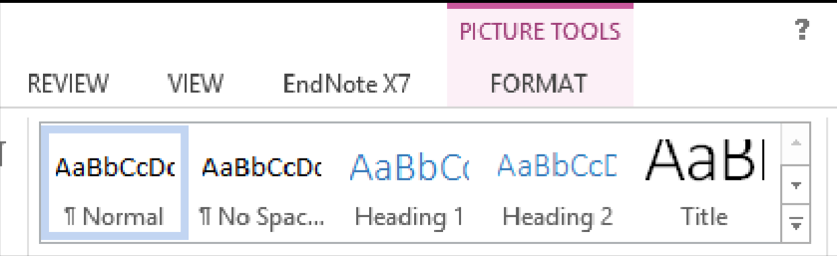

**To Create a New Word Document:**

1) Click the File tab

2) Click New

3) Click Blank Document

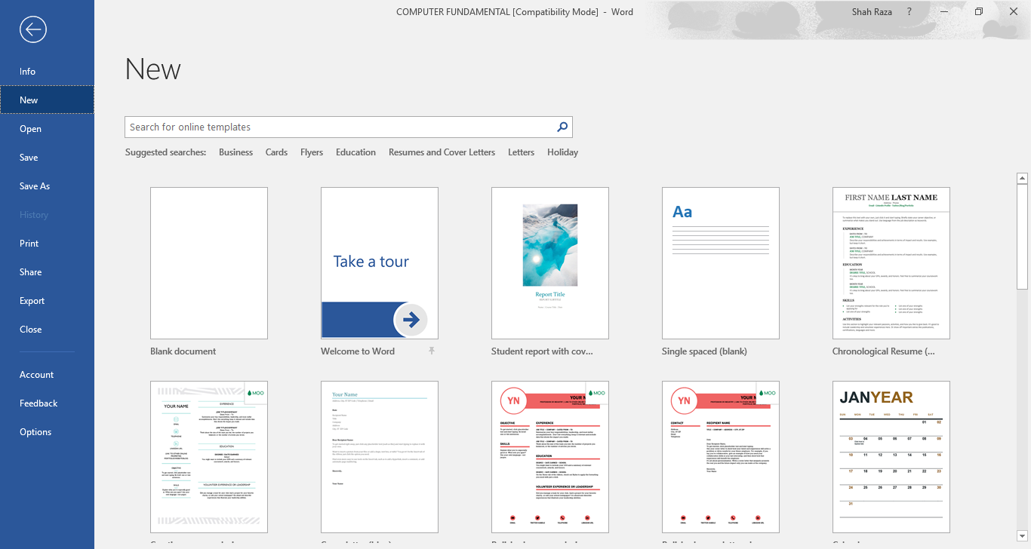

# **Navigating in a Document**

The following table lists ways to navigate in a document using your keyboard to move the insertion point in an active document:

|  |  |
| --- | --- |
| To move the insertion point | Press |
| Left one character | Left Arrow |
| Right one character | Right Arrow |
| Down one line | Down Arrow |
| Up one line | Up Arrow |
| Left one word | CTRL + Left Arrow |
| Right one word | CTRL + Right Arrow |
| To the beginning of the current line | Home |
| To the end of the current line | End |
| To the beginning of the document | CTRL + Home |
| To the end of the document | CTRL + End |
| To the beginning of the previous page | CTRL + Page Up |
| To the beginning of the next page | CTRL + Page Down |
| Up one screen | Page Up |
| Down one screen | Page Down |

**To Display Different Views:**

1) Click the View tab

2) Click on the desired view

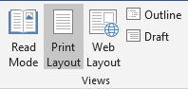

**View Options:**

* **Read Mode:** Displays as much of the content of the document as will fit in the screen.
* **Print Layout View:** Shows a document as it appears on a printed page.
* **Web Layout View**: Shows a document as it appears in a web browser.
* **Outline View:** Shows the structure of a document, which consist of heading and body text.
* **Draft View:** Displays the content of a document with a basic layout.

~OR~

3) Click a View button on the View Toolbar in the lower right corner of the Status Bar.



# **Editing and Proofing Documents**

## **Selecting Text**

* **Select a word:** Click and drag or double-click on the word.
* **Select a sentence:** Click and drag or click in the sentence while holding down the CTRL key.
* **Select a paragraph:** Click and drag or triple-click in the paragraph or double-click in the selection area to the left of the paragraph.
* **Select a block of text:** Click and drag or click to the left of the first word, hold down the SHIFT key, and then immediately click to the right of the last word.
* **Select a line:** Click and drag or click in the selection to the left of the line.
* **Select an entire document:** Triple-click in the selection area or hit the CTRL + A keys.
* **Undo an action:** On the Quick Access Toolbar click the Undo key.

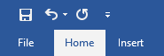

**Undo**

## **Deleting Text**

When deleting text in your document you can either use the Delete key or the Backspace key. The Delete key deletes text to the right of your cursor while the Backspace key deletes text to the left of your cursor.

## **Cut, Copy and Paste**

Often times you will need to move text from one location in a document to another, or to a different application. In this case you will perform a Cut and Paste.To reproduce a specific part of a document and place it elsewhere, you will perform a Copy and Paste.

## **To Cut Text:**

1) Select the text you want to move.

2) Click on the Cut icon  located on the Home tab in the Clipboard group.

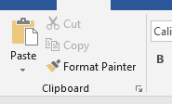

**To Copy Text:**

1) Select the text you want to copy.

2) Click on the Copy icon  located on the Home tab in the Clipboard group.

**To Paste Text:**

1) Click in the area of the document where you want to paste your text.

2) Click on the Paste icon  located on the Home tab in the Clipboard group.

**Formatting a Document to Make Font Changes:**

1) Select the desired text that you want to format.

2) Choose commands from the Font group on the Home tab.

3) For additional formatting options, click on the Dialog Box Launcher in the lower-right corner of the group to launch the Font dialog box.

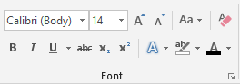 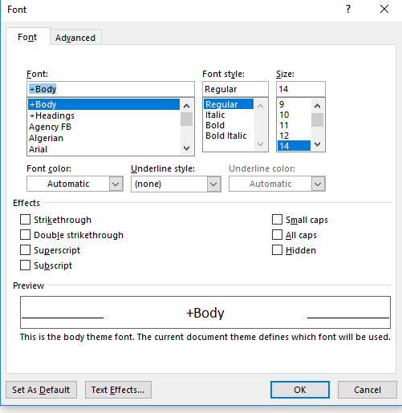

You can also use the **MiniTool bar**. The Mini Toolbar is activated when you select text to be formatted. This toolbar is miniature and semi-transparent to help you work with fonts, font styles, font sizing, alignment, text color, indent levels, and bullet features.

# **Working with Graphics**

**Inserting Shapes:**

You can add one shape to your file or combine multiple shapes to make a drawing or a more complex shape. Available shapes include lines, basic geometric shapes, arrows, equation shapes, flowchart shapes, stars, banners, and callouts. After you add one or more shapes, you can add text, bullets, numbering, and Quick Styles to them.

1. On the Insert tab, in the Illustrations group, click Shapes.

2. A drop down menu will appear, click the shape that you want.

3. Click anywhere in the document, and then drag to place the shape.

**Insert Text to Shapes:**

Once you have added a shape, you may want to add text inside the shape. All you have to do is click on the inside of the shape and start typing.

**Format Shapes:**

After you insert a shape a new tab called Drawing Tools Format will appear every time you click on the shape.

1. Click the shape that you want to apply a new or different Quick

Style to.

2. Go to the Drawing Tools Format tab, in the Shape Styles group, click the style that you want to be applied.

3. To see more Quick Styles, click More button. The Drawing Tools Format Tab also allows you to change the shape fill, outline, effects and select how the text in your document is wrapped around the shape

**Inserting Text Boxes:**

A text box is an object that lets you put and type text anywhere in your file.

1. On the Insert tab, in the Text group, click Text Box and a drop-down menu will appear.

2. Click on a text box template or click Draw Text Box at the bottom of the drop-down menu to draw your own text box.

3. If you elect to draw your own text box you need to click in the document, and then drag to draw the text box the size that you want.

4. To add text to a text box, click inside the text box, and then type or paste text.

To format text in the text box, select the text, and then use the formatting options in the Font group on the Home tab. To position the text box, click it, and then when the pointer becomes a, drag the text box to a new location.

**WordArt:**

WordArt can be used to add special text effects to your document. For example, you can stretch a title, skew text, make text fit a preset shape, or apply a gradient fill. This WordArt becomes an object that you can move or position in your document to add decoration or emphasis. You can modify or add to the text in an existing WordArt object whenever you want. To add WordArt to text in your document, complete the following steps:

1. On the Insert tab, in the Text group, click WordArt,

2. A Drop-down menu will appear, click the WordArt style that you want.

3. A Text Box will appear with the words” Enter your text here”, Enter your text.

**Inserting Equations:**

To insert an equation into a word document, do the following steps:

1. Open **Insert.**
2. Click on **Equation.**

Some Equations:

$$\sin{α}±\sin{β}=2\sin{\frac{1}{2}\left(α±β\right)}\cos{\frac{1}{2}\left(α∓β\right)}$$

$${\left(1+x\right)}^{n}=1+\frac{nx}{1!}+\frac{n\left(n-1\right)x^{2}}{2!}+…$$

$$x=\frac{-b±\sqrt{b^{2}-4ac}}{2a}$$

$$\lim_{n→∞}{{\left(1+\frac{1}{n}\right)}^{n}}$$

$$\left[\begin{matrix}4 & 5 \\ 8 & 1\end{matrix}\right]$$

# **Live Preview**

Using Live Preview temporarily applies formatting on selected text or objects whenever a formatting command is hovered. This allows you to quickly preview how the formatting options will look before they are made.

1. Select the desired text that you want to format
2. On the Home tab, in the Font group, do any of the following:
3. Click the arrow next to the Font box and move the pointer over the fonts that you want to preview.
4. Click the arrow next to the Font Size box and move the pointer over the font sizes that you want to preview.
5. Click the arrow next to the Text Highlight Color button and move the pointer over the highlight or fill colors that you want to preview.
6. Click the arrow next to the Font Color button and move the pointer over the font colors that you want to preview.

When you finish previewing the formatting choices, do one of the following:

* To apply the previewed formatting, click the selected font name, size, or color in the list.
* To cancel live previewing without applying any changes, press ESC.

# **Formatting a Paragraph**

A paragraph is a select group of text that can have its own formatting characteristics, such as alignment, spacing and styles.

1. Select the desired paragraph(s) that you want to format.
2. Choose commands from the Paragraph group on the Home tab.
3. For additional formatting options, click on the Dialog Box Launcher in the lower-right corner of the group to launch the Paragraph dialog box.

# **Previewing and Printing a Document**

1. Click the File tab.
2. Click Print

This view includes print preview, print commands, as well as the print settings:

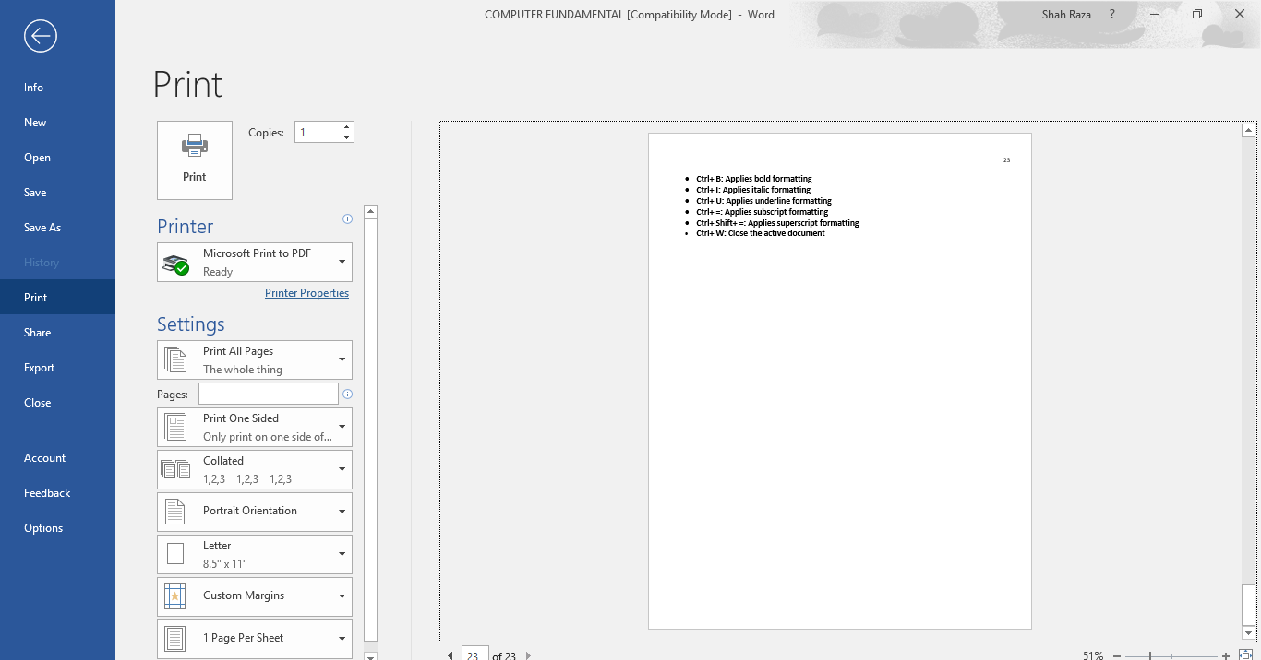

# **Saving and Closing a New Document**

## **To Save a New Document**

1. On the Quick Access Toolbar, click the Save button.



~OR~

1. Click the File tab.
2. Click Save As.
3. Select the location, the Save As dialog box will appear.

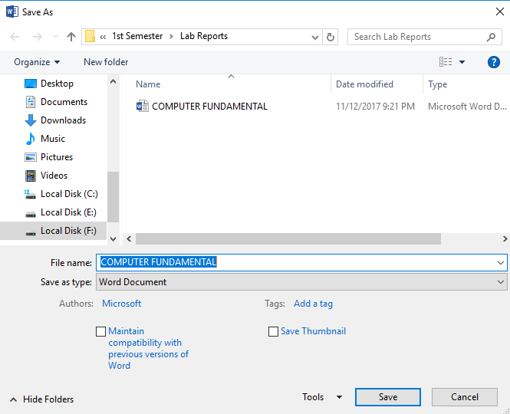

1. In the File Name field, type the name of the document.
2. Click Save.

## **To Close a Document**

1. Click the File tab, and then click Close.
2. If a Microsoft Office Word dialog box appears displaying a “Do you want to save…?” message:

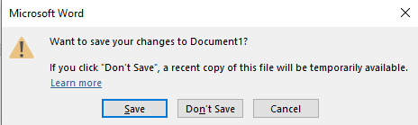

Click **Save** to save, **Don’t Save** to discard changes, or **Cancel** to close the dialog box.